

**软件测试课程设计报告**

学 号：

班级序号：

学生姓名：

指导教师： 张建波

**中国地质大学计算机学院软件工程系**

**2022年 8 月**

# 一、动态测试技术

## 1. 软件说明

**软件名称：《**国航行李计算器》

**软件功能：**该软件可以根据用户输入的乘客类型、航班类型、舱位属性、会员等级、行李数量、各行李参数等参数计算行李运输所需价格，其逻辑设计部分根据国航官方文档设计。

**实现技术：**前端设计：vue+element-ui, 后端: spring-boot, 开发环境: IntelliJ IDEA 2021.2.2专业版，测试框架: Junit。

**前端开发：**采用vue进行前端页面的设计，使用element-ui辅助页面渲染及可视化。在前端中，用户需选择乘客类型、航班类型、舱位属性、会员等级、行李数目，输入机票价格，当用户选择行李数目后，页面右侧将出现对应数量的行李规格填写框与行李属性选择框，同时，设置vue中的rule使得前端对用户的输入采取一定的校验规则，如必选属性必须被选择，行李价格应处于1-100000的范围等，在通过校验后，表单才会被传递到后端进行处理。在页面底部，附有对飞行区域的说明，以增强与用户间的交互性。

**后端开发：**后端采取springboot设计框架，并采用MVC设计模式，其中Controller层接收数据，需要调用Service中的接口控制业务逻辑；Service层编写复杂业务逻辑判断；Entity内存放各表对象实体类；

经阅读文档并梳理逻辑，我发现行李的费用分为普通行李费用和特殊行李费用，且特殊行李费用的计算与用户属性、舱位属性等均无关，因此可以单独计算。

国内航班与国内航班分别有两大重要的特点，即国内航班为计重制，而国外航班为计件制，因此首先划分国内航班与国外航班，分别计算各类用户在所属舱位、会员制下免费运输的行李数量，判断用户携带行李是否超额，若超额再对超限额数量的行李进行价格计算。

**前端页面展示：**

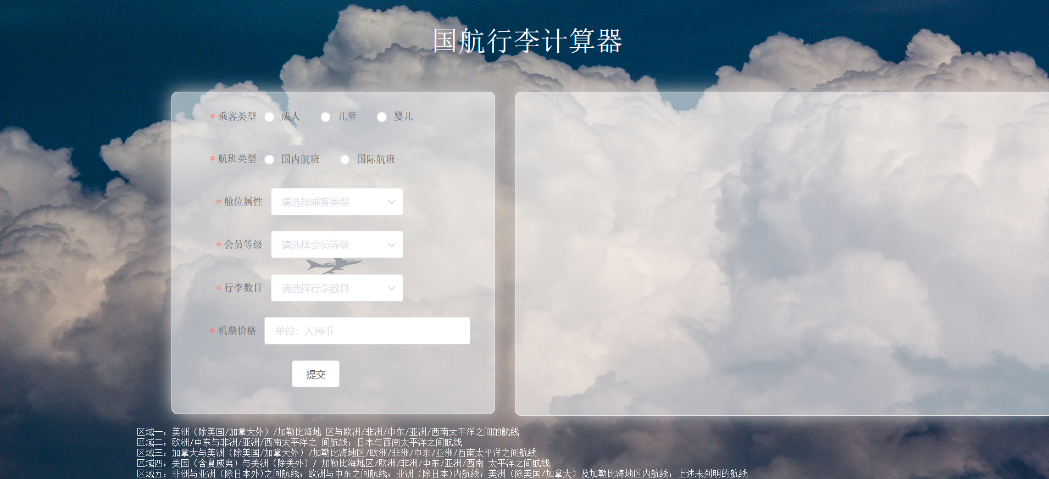

（整体展示）

根据用户选择航班类型不同，左侧表单也会有差异，默认飞行区域不显示，只有当用户选择国际航班时才显示飞行区域选择框：

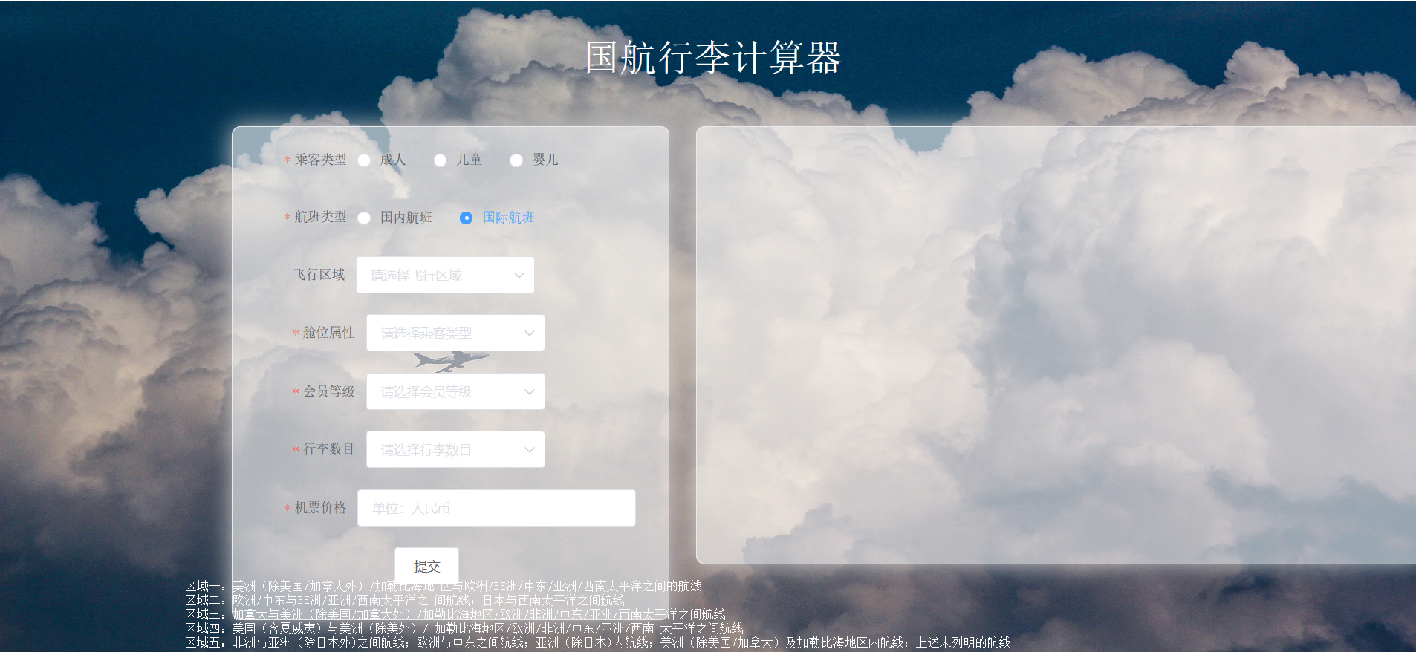

（选择国际航班时飞行区域选择框才会显示）

当用户选择不同的行李数目时，页面右侧会出现相应数量的行李属性填写框：

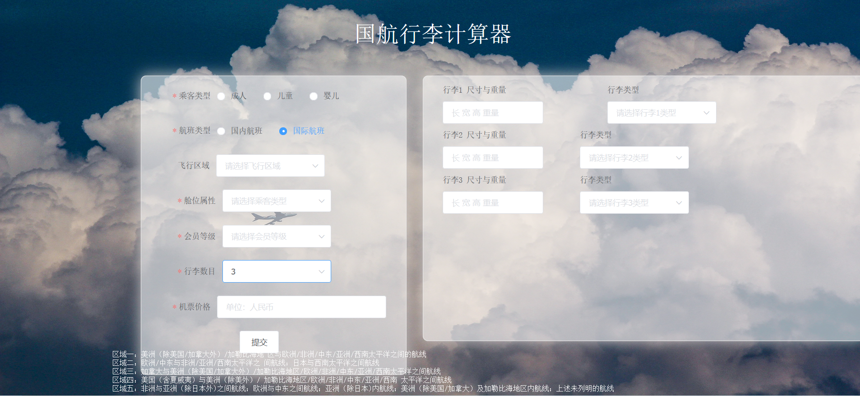

（当用户选择三个行李）

用户点击提交按钮时前端会进行表单验证，若未通过验证则会出现对应错误提示：

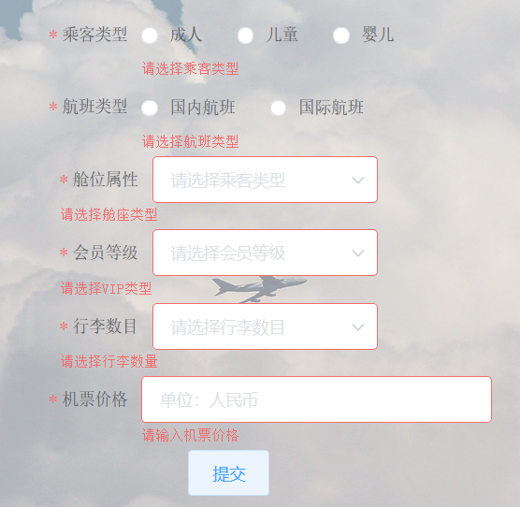

（当必填属性未填写时）

计算成功后，页面跳出对话框显示行李价格：

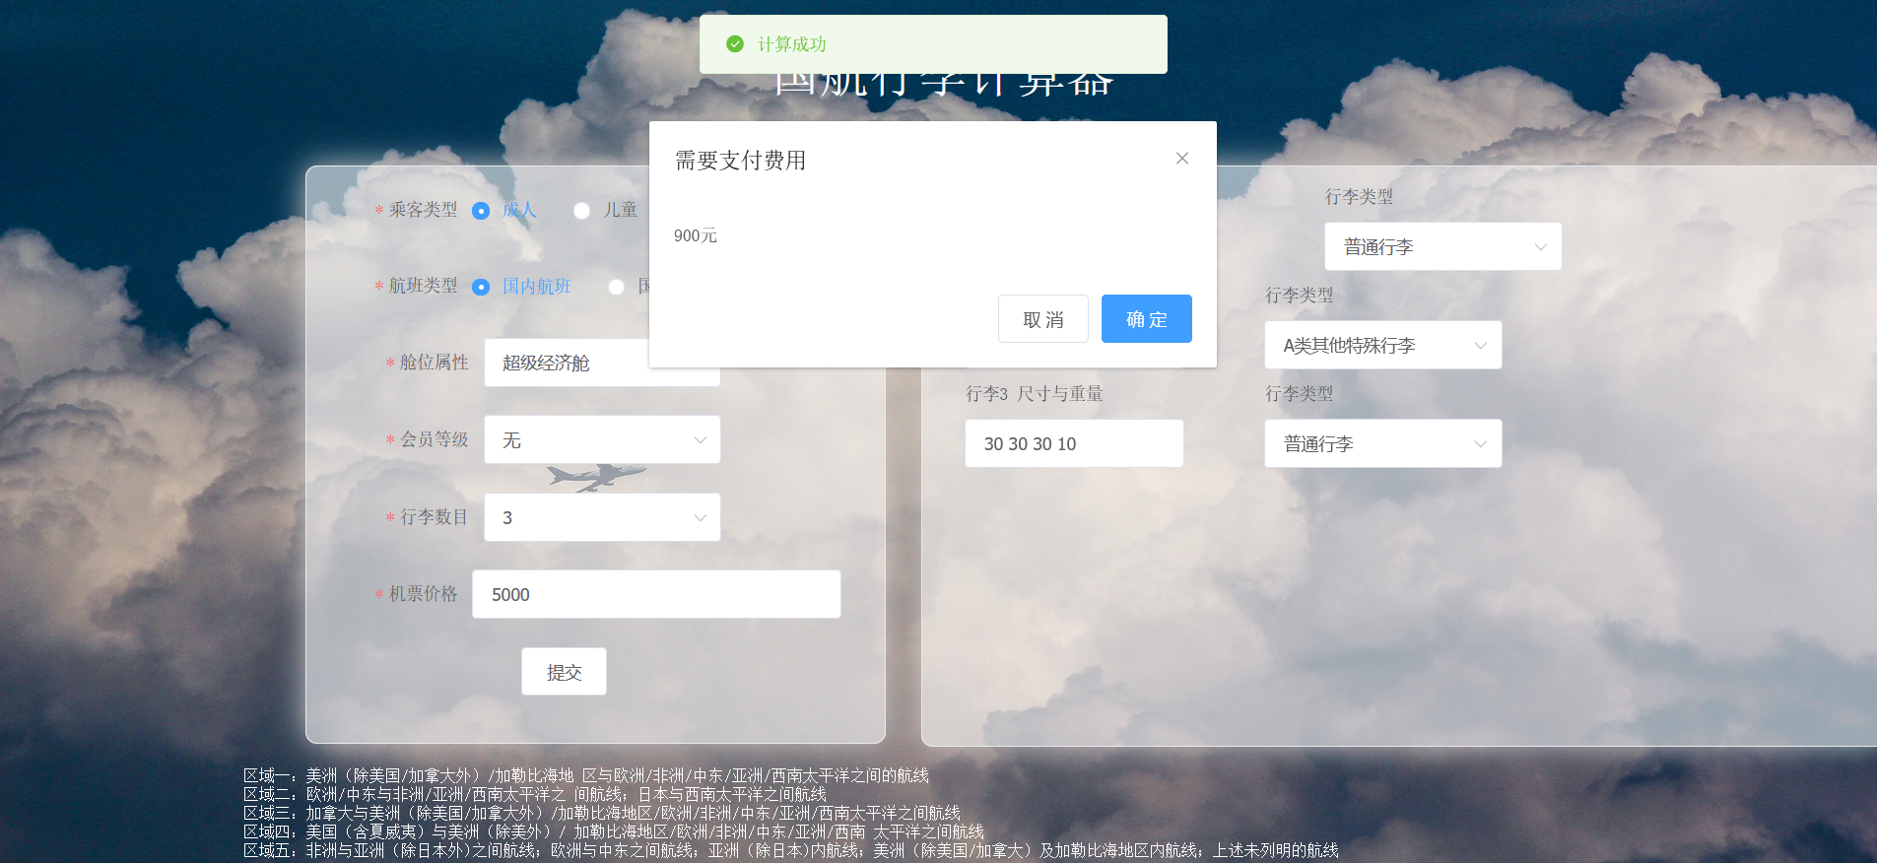

若用户行李规格输入不符合要求，页面同样也会弹出提示框提示：

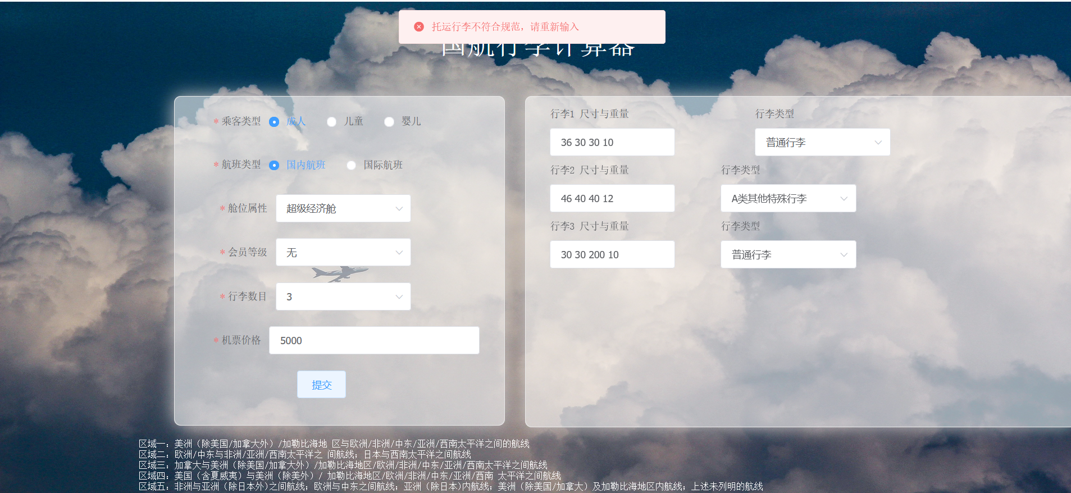

（如图可见，行李3尺寸过大，不予运输）

## 2. 软件功能结构图（XMind）

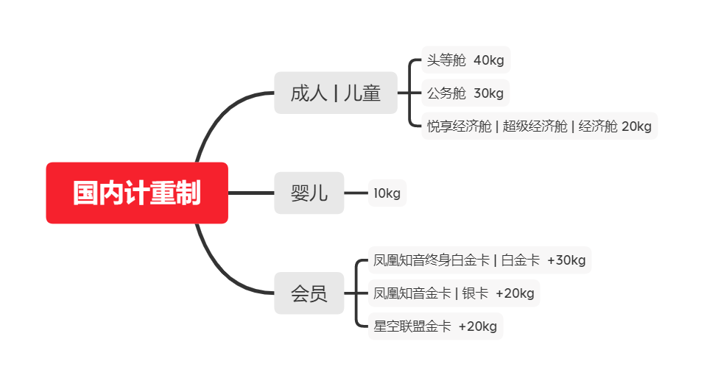

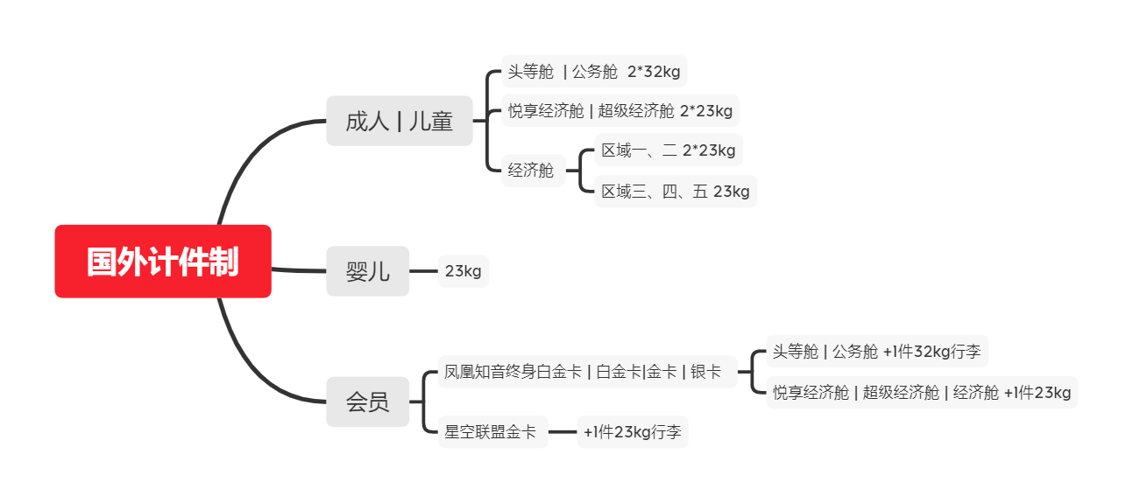

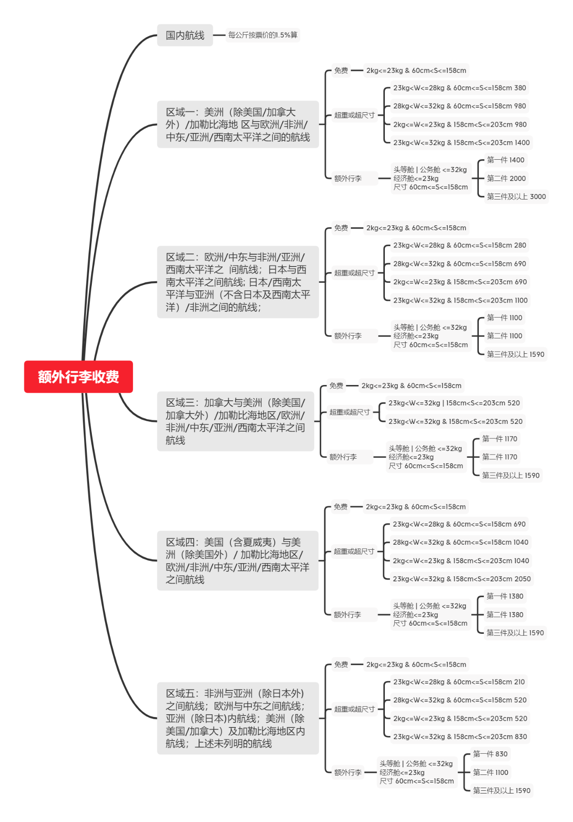

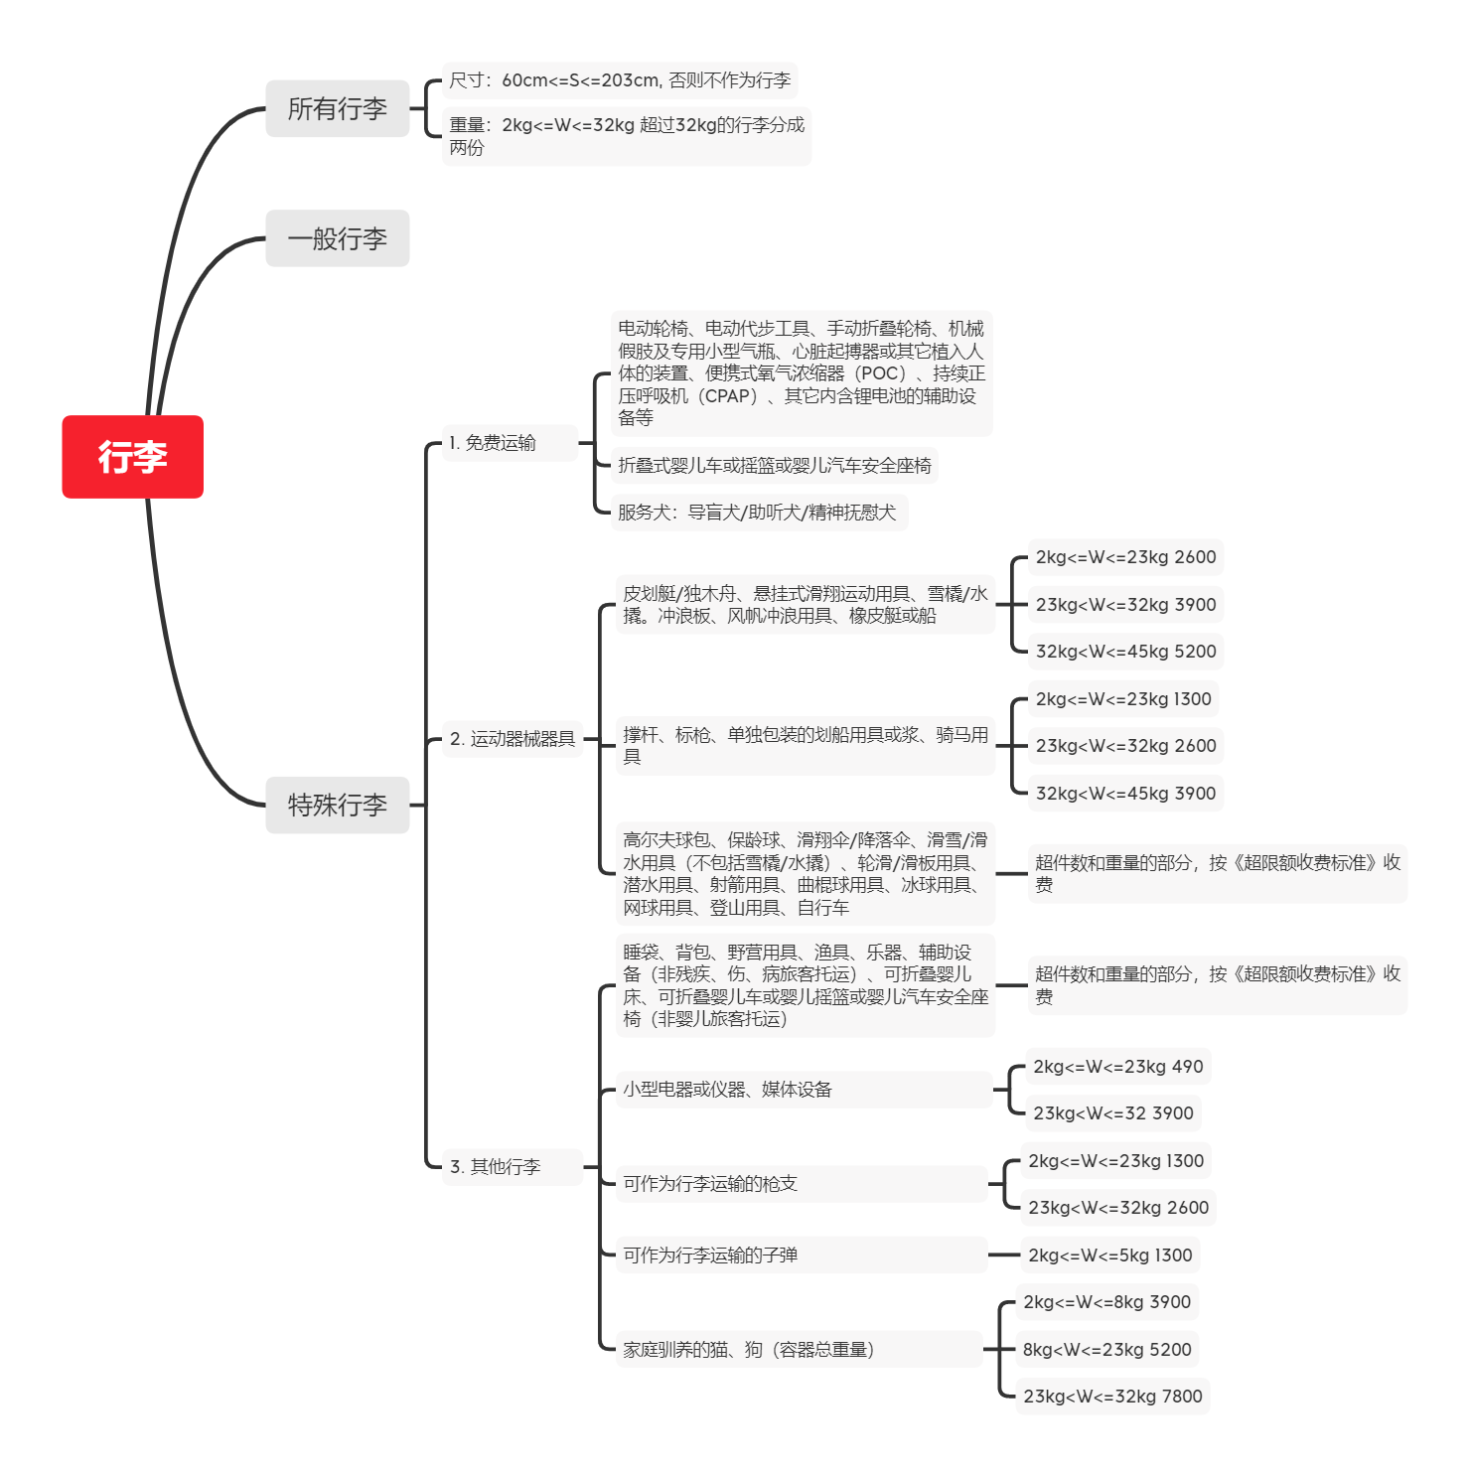

## 3. 黑盒测试

**表1-1 不区分国内国际航班的等价类划分表**

|  |  |  |  |
| --- | --- | --- | --- |
| 序号 | 输入条件 | 编号，有效等价类 | 编号，无效等价类 |
| 1 | 旅客类型 | 1.1成人  1.2儿童  1.3婴儿 | 1.4其他类型 |
| 2 | 舱位类型 | 2.1头等舱  2.2公务舱  2.3悦享经济舱  2.4超级经济舱  2.5经济舱 | 2.6其他类型 |
| 3 | VIP类型 | 3.1无VIP  3.2凤凰知音终身白金卡  3.3凤凰知音白金卡  3.4凤凰知音金卡  3.5凤凰知音银卡  3.6星空联盟金卡 | 3.7其他类型 |
| 4 | 行李尺寸 | 4.1长宽高之和大于等于60cm且小于等于203cm | 4.2长宽高之和小于60cm  4.3长宽高之和大于203cm  4.4非纯数字类型 |
| 5 | 普通行李/C类运动器械器具/ABCE类其他特殊行李重量 | 5.1大于等于2kg且小于等于32kg | 5.2小于2kg  5.3大于32kg |
| 6 | AB类运动器械器具质量 | 6.1大于等于2kg且小于等于45kg | 6.2小于2kg  6.3大于45kg |
| 7 | D类其他特殊行李质量 | 7.1大于等于2kg且小于等于5kg | 7.2小于2kg  7.3大于5kg |
| 8 | 行李类型 | 8.1普通行李  8.2可免费携带的特殊行李  8.3A类运动器械器具  8.4B类运动器械器具  8.5C类运动器械器具  8.6A类其他特殊行李  8.7B类其他特殊行李  8.8C类其他特殊行李  8.9D类其他特殊行李  8.10E类其他特殊行李 | 8.11其他类型行李 |
| 9 | 行李数量 | 9.1大于0小于7 | 9.2小于0  9.3大于7 |
| 10 | 机票价格 | 10.1大于0小于100000 | 10.2负数  10.3小于0  10.4 大于100000  10.5 等于100000  10.6非纯数字类型 |
| 11 | 飞行区域 | 11.1区域一  11.2区域二  11.3区域三  11.4区域四  11.5区域五 | 11.6其他区域 |
| 12 | 航班类型 | 12.1 国内航班  12.2国际航班 | 12.3其他航班 |

**表1-2 测试用例设计表**

|  |  |  |  |  |
| --- | --- | --- | --- | --- |
| 用例编号 | 用例操作描述 | 测试数据 | 期望结果 | 覆盖等价类 |
|  | **覆盖无效等价类**  **（一次只覆盖一个）** |  |  |  |
| 1 | 行李长宽高之和小于60cm | {"region":"","person":"成人","seat_type":"s1","flight_type":"国内航班","vip":"v1","num":"1","length1":"10 10 10 10","type1":"普通行李","length2":"","type2":"","length3":"","type3":"","price":"5000"} | -1 | 4.2 |
| 2 | 行李长宽高之和大于203cm | {"region":"","person":"成人","seat_type":"s1","flight_type":"国内航班","vip":"v1","num":"1","length1":"100 100 100 10","type1":"普通行李","length2":"","type2":"","length3":"","type3":"","price":"5000"} | -1 | 4.3 |
| 3 | 行李尺寸为非纯数字类型 | {"region":"","person":"成人","seat_type":"s1","flight_type":"国内航班","vip":"v1","num":"1","length1":"1+ 10 60 10","type1":"普通行李","length2":"","type2":"","length3":"","type3":"","price":"5000"} | -1 | 4.4 |
| 4 | 普通行李/C类运动器械器具/ABCE类其他特殊行李重量小于2kg | {"region":"","person":"成人","seat_type":"s1","flight_type":"国内航班","vip":"v1","num":"1","length1":"30 30 30 1","type1":"C类运动器械器具","length2":"","type2":"","length3":"","type3":"","price":"5000"} | -1 | 5.2 |
| 5 | 普通行李/C类运动器械器具/ABCE类其他特殊行李重大于32kg | {"region":"","person":"成人","seat_type":"s1","flight_type":"国内航班","vip":"v1","num":"1","length1":"30 30 30 33","type1":"C类运动器械器具","length2":"","type2":"","length3":"","type3":"","price":"5000"} | -1 | 5.3 |
| 6 | AB类运动器械器具质量小于2kg | {"region":"","person":"成人","seat_type":"s1","flight_type":"国内航班","vip":"v1","num":"1","length1":"30 30 30 1","type1":"A类运动器械器具","length2":"","type2":"","length3":"","type3":"","price":"5000"} | -1 | 6.2 |
| 7 | AB类运动器械器具质量大于45kg | {"region":"","person":"成人","seat_type":"s1","flight_type":"国内航班","vip":"v1","num":"1","length1":"30 30 30 46","type1":"A类运动器械器具","length2":"","type2":"","length3":"","type3":"","price":"5000"} | -1 | 6.3 |
| 8 | D类其他特殊行李质量小于2kg | {"region":"","person":"成人","seat_type":"s1","flight_type":"国内航班","vip":"v1","num":"1","length1":"30 30 30 1","type1":"D类其他特殊行李","length2":"","type2":"","length3":"","type3":"","price":"5000"} | -1 | 7.2 |
| 9 | D类其他特殊行李质量大于5kg | {"region":"","person":"成人","seat_type":"s1","flight_type":"国内航班","vip":"v1","num":"1","length1":"30 30 30 6","type1":"D类其他特殊行李","length2":"","type2":"","length3":"","type3":"","price":"5000"} | -1 | 7.3 |
| 10 | 机票价格小于0 | {"region":"","person":"成人","seat_type":"s1","flight_type":"国内航班","vip":"v1","num":"1","length1":"30 30 30 10","type1":"普通行李","length2":"","type2":"","length3":"","type3":"","price":"-1"} | -1 | 10.3 |
| 11 | 机票价格等于0 | {"region":"","person":"成人","seat_type":"s1","flight_type":"国内航班","vip":"v1","num":"1","length1":"30 30 30 10","type1":"普通行李","length2":"","type2":"","length3":"","type3":"","price":"0"} | -1 | 10.2 |
| 12 | 机票价格大于100000 | {"region":"","person":"成人","seat_type":"s1","flight_type":"国内航班","vip":"v1","num":"1","length1":"30 30 30 10","type1":"普通行李","length2":"","type2":"","length3":"","type3":"","price":"10000000"} | -1 | 10.4 |
| 13 | 机票价格等于100000 | {"region":"","person":"成人","seat_type":"s1","flight_type":"国内航班","vip":"v1","num":"1","length1":"30 30 30 10","type1":"普通行李","length2":"","type2":"","length3":"","type3":"","price":"100000"} | -1 | 10.5 |
| 14 | 机票价格为非纯数字类型 | {"region":"","person":"成人","seat_type":"s1","flight_type":"国内航班","vip":"v1","num":"1","length1":"30 30 30 10","type1":"普通行李","length2":"","type2":"","length3":"","type3":"","price":"*123"} | -1 | 10.6 |
|  | **覆盖有效等价类**  **（一次尽量覆盖最多）** |  |  |  |
| 15 | 成人+头等舱+无VIP+正常尺寸+普通行李正常重量+A类运动器械器具正常质量+正常数量+1件普通行李+1件可免费携带的特殊行李+1件A类运动器械器具+正常机票价格+国内航班 | {"region":"","person":"成人","seat_type":"s1","flight_type":"国内航班","vip":"v0","num":"3","length1":"30 30 30 10","type1":"普通行李","length2":"30 30 30 10","type2":"A类运动器械器具","length3":"30 30 30 10","type3":"可免费携带的特殊行李","price":"5000"} | 0 | 1.1  2.1  3.1  4.1  5.1  6.1  8.1  8.2  8.3  9.1  10.1 |
| 16 | 儿童+公务舱+凤凰知音终身白金卡+正常尺寸+BC类运动器械器具正常质量+A类其他特殊行李正常质量（2件）+区域一+国际航班 | {"region":"r1","person":"儿童","seat_type":"s2","flight_type":"国际航班","vip":"v1","num":"3","length1":"30 30 30 3","type1":"B类运动器械器具","length2":"30 30 30 3","type2":"C类运动器械器具","length3":"30 30 30 3","type3":"A类其他特殊行李","price":"5000"} | 5200 | 1.2  2.2  3.2  4.1  5.1  7.1  8.4  8.5  8.6  9.1  10.1  11.1  12.2 |
| 17 | 婴儿+悦享经济舱+凤凰知音白金卡+BCD类其他特殊行李（3件）+区域二+国际航班 | {"region":"r2","person":"婴儿","seat_type":"s3","flight_type":"国际航班","vip":"v2","num":"3","length1":"30 30 30 3","type1":"B类其他特殊行李","length2":"30 30 30 3","type2":"C类其他特殊行李","length3":"30 30 30 3","type3":"D类其他特殊行李","price":"5000"} | 3090 | 1.3  2.3  3.3  4.1  5.1  8.7  8.8  8.9  9.1  10.1  11.2  12.2 |
| 18 | 成人+超级经济舱+凤凰知音金卡+E类其他特殊行李+区域三+国际航班 | {"region":"r3","person":"成人","seat_type":"s4","flight_type":"国际航班","vip":"v3","num":"1","length1":"30 30 30 3","type1":"E类其他特殊行李","length2":"","type2":"","length3":"","type3":"","price":"5000"} | 3900 | 1.1  2.4  3.4  4.1  5.1  8.10  9.1  10.1  11.3  12.2 |
| 19 | 成人+经济舱+凤凰知音银卡+1件普通行李正常尺寸重量+国际航班+区域四 | {"region":"r4","person":"成人","seat_type":"s5","flight_type":"国际航班","vip":"v4","num":"1","length1":"30 30 30 3","type1":"普通行李","length2":"","type2":"","length3":"","type3":"","price":"5000"} | 0 | 1.1  2.5  3.5  4.1  5.1  8.1  9.1  10.1  11.4  12.2 |
| 20 | 成人+经济舱+星空联盟金卡+1件普通行李正常尺寸重量+区域五+国际航班 | {"region":"r5","person":"成人","seat_type":"s5","flight_type":"国际航班","vip":"v5","num":"1","length1":"30 30 30 3","type1":"普通行李","length2":"","type2":"","length3":"","type3":"","price":"5000"} | 0 | 1.1  2.5  3.6  4.1  5.1  8.1  9.1  10.1  11.5  12.2 |

注：由于很多输入情况在前端设计时已提前限制好，如飞行区域、用户类型、舱位类型、VIP属性行李类型、行李数量都只能在提供的下拉框或单选按钮中选择，用户无法选择其他类型的属性，因此对于这些属性的无效等价类无法被覆盖到。

除去以上无效等价类外，黑盒测试覆盖率为100%

## 4. 白盒测试

### 4.1 模块1：国内航班

**4.1.1 功能**

计算当用户选择国内航班时的行李价格。

流程图如下：

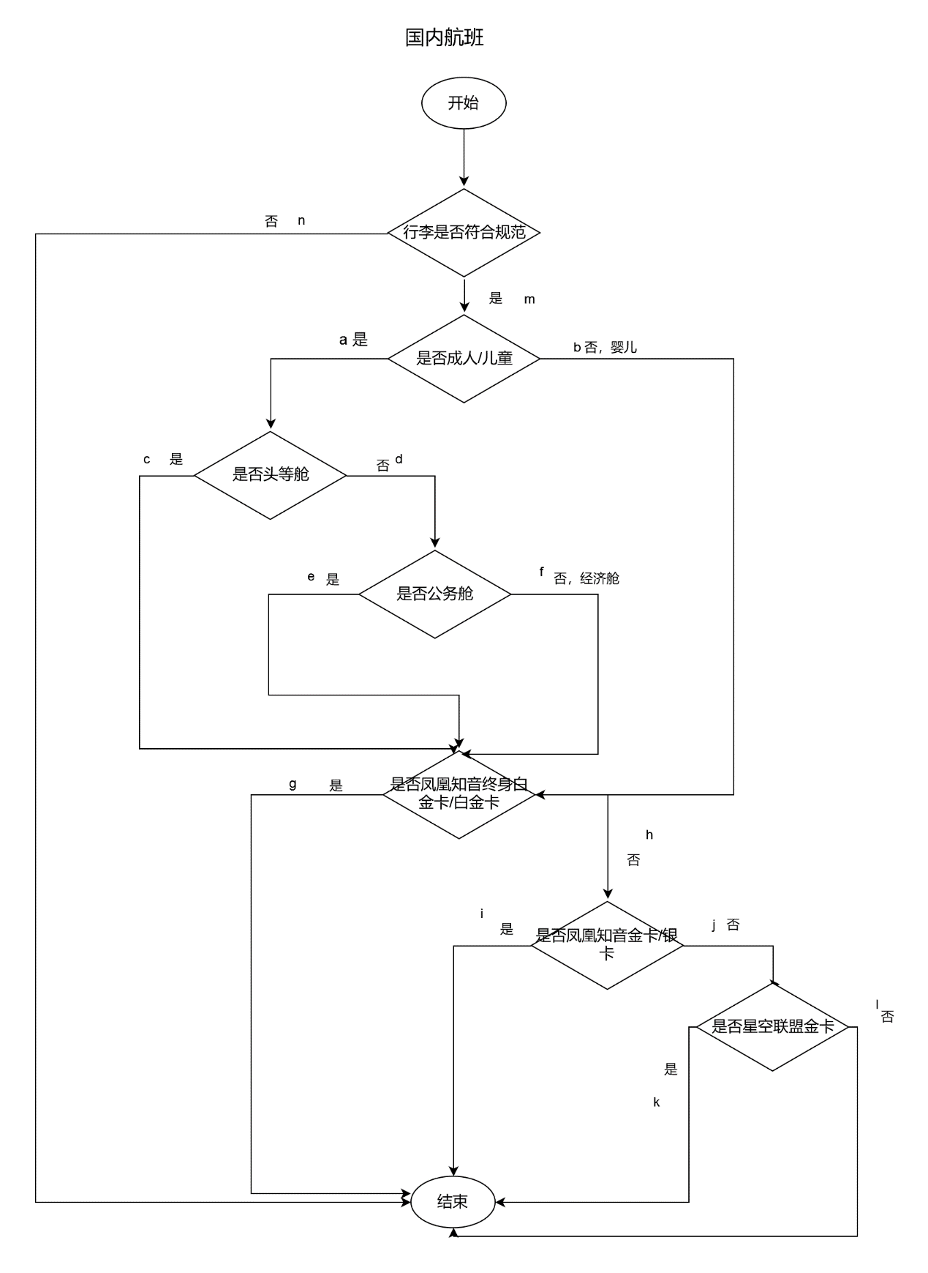

**4.1.2 输入**

乘客类型、会员等级、舱位等级、机票价格、行李数量、各行李的规格及类型。

**4.1.3 输出**

错误数据返回-1；

运行正常返回的是行李托运计算结果

**4.1.4 测试用例**

**表4-1 国内航班测试用例设计表**

|  |  |  |  |
| --- | --- | --- | --- |
| 用例编号 | 通过路径 | 测试数据 | 期望结果 |
| 1 | m-a-c-g | {"region":"","person":"成人","seat_type":"s1","flight_type":"国内航班","vip":"v1","num":"3","length1":"30 30 30 30","type1":"普通行李","length2":"30 30 30 30","type2":"A类运动器械器具","length3":"30 30 30 30","type3":"普通行李","price":"5000"} | 1500 |
| 2 | m-a-c-h-i | {"region":"","person":"成人","seat_type":"s1","flight_type":"国内航班","vip":"v3","num":"3","length1":"31 30 30 30","type1":"普通行李","length2":"31 30 30 30","type2":"A类运动器械器具","length3":"31 30 30 30","type3":"普通行李","price":"5000"}, | 2250 |
| 3 | m-a-c-h-j-k | {"region":"","person":"成人","seat_type":"s1","flight_type":"国内航班","vip":"v5","num":"3","length1":"32 30 30 30","type1":"普通行李","length2":"32 30 30 30","type2":"A类运动器械器具","length3":"32 30 30 30","type3":"普通行李","price":"5000"} | 2250 |
| 4 | m-a-c-h-j-l | {"region":"","person":"成人","seat_type":"s1","flight_type":"国内航班","vip":"v0","num":"3","length1":"33 30 30 30","type1":"普通行李","length2":"33 30 30 30","type2":"A类运动器械器具","length3":"33 30 30 30","type3":"普通行李","price":"5000"} | 3750 |
| 5 | m-a-d-e-g | {"region":"","person":"成人","seat_type":"s2","flight_type":"国内航班","vip":"v1","num":"3","length1":"34 30 30 30","type1":"普通行李","length2":"34 30 30 30","type2":"A类运动器械器具","length3":"34 30 30 30","type3":"普通行李","price":"5000"} | 2250 |
| 6 | m-a-d-e-h-i | {"region":"","person":"成人","seat_type":"s2","flight_type":"国内航班","vip":"v3","num":"3","length1":"35 30 30 30","type1":"普通行李","length2":"35 30 30 30","type2":"A类运动器械器具","length3":"35 30 30 30","type3":"普通行李","price":"5000"} | 3000 |
| 7 | m-a-d-e-h-j-k | {"region":"","person":"成人","seat_type":"s2","flight_type":"国内航班","vip":"v5","num":"3","length1":"36 30 30 30","type1":"普通行李","length2":"36 30 30 30","type2":"A类运动器械器具","length3":"36 30 30 30","type3":"普通行李","price":"5000"} | 3000 |
| 8 | m-a-d-e-h-j-l | {"region":"","person":"成人","seat_type":"s2","flight_type":"国内航班","vip":"v0","num":"3","length1":"37 30 30 30","type1":"普通行李","length2":"37 30 30 30","type2":"A类其他特殊行李","length3":"37 30 30 30","type3":"普通行李","price":"5000"} | 4500 |
| 9 | m-a-d-f-g | {"region":"","person":"成人","seat_type":"s3","flight_type":"国内航班","vip":"v1","num":"2","length1":"30 30 30 10","type1":"普通行李","length2":"40 40 40 12","type2":"A类其他特殊行李","length3":"","type3":"","price":"5000"} | 0 |
| 10 | m-a-d-f-h-i | {"region":"","person":"成人","seat_type":"s3","flight_type":"国内航班","vip":"v3","num":"2","length1":"31 30 30 10","type1":"普通行李","length2":"41 40 40 12","type2":"A类其他特殊行李","length3":"","type3":"","price":"5000"} | 0 |
| 11 | m-a-d-f-h-j-k | {"region":"","person":"成人","seat_type":"s3","flight_type":"国内航班","vip":"v5","num":"2","length1":"32 30 30 10","type1":"普通行李","length2":"42 40 40 12","type2":"A类其他特殊行李","length3":"","type3":"","price":"5000"} | 0 |
| 12 | m-a-d-f-h-j-l | {"region":"","person":"成人","seat_type":"s3","flight_type":"国内航班","vip":"v0","num":"2","length1":"33 30 30 10","type1":"普通行李","length2":"43 40 40 12","type2":"A类其他特殊行李","length3":"","type3":"","price":"5000"} | 0 |
| 13 | m-b-g | {"region":"","person":"婴儿","seat_type":"s4","flight_type":"国内航班","vip":"v1","num":"1","length1":"34 30 30 10","type1":"普通行李","length2":"","type2":"","length3":"","type3":"","price":"5000"} | 0 |
| 14 | m-b-h-i | {"region":"","person":"婴儿","seat_type":"s4","flight_type":"国内航班","vip":"v3","num":"1","length1":"35 30 30 10","type1":"普通行李","length2":"","type2":"","length3":"","type3":"","price":"5000"} | 0 |
| 15 | m-b-h-j-k | {"region":"","person":"婴儿","seat_type":"s4","flight_type":"国内航班","vip":"v5","num":"2","length1":"36 30 30 10","type1":"普通行李","length2":"46 40 40 12","type2":"A类其他特殊行李","length3":"","type3":"","price":"5000"} | 0 |
| 16 | m-b-h-j-l | {"region":"","person":"婴儿","seat_type":"s4","flight_type":"国内航班","vip":"v0","num":"2","length1":"37 30 30 10","type1":"普通行李","length2":"47 40 40 12","type2":"A类其他特殊行李","length3":"","type3":"","price":"5000"} | 900 |
| 17 | n | {"region":"","person":"成人","seat_type":"s5","flight_type":"国内航班","vip":"v0","num":"2","length1":"90 90 90 10","type1":"普通行李","length2":"40 40 40 12","type2":"A类其他特殊行李","length3":"","type3":"","price":"5000"} | -1 |

白盒测试覆盖率：100%

### 4.2 模块2：国际航班

**4.2.1 功能**

计算当用户选择国际航班时的行李价格。

流程图如下：

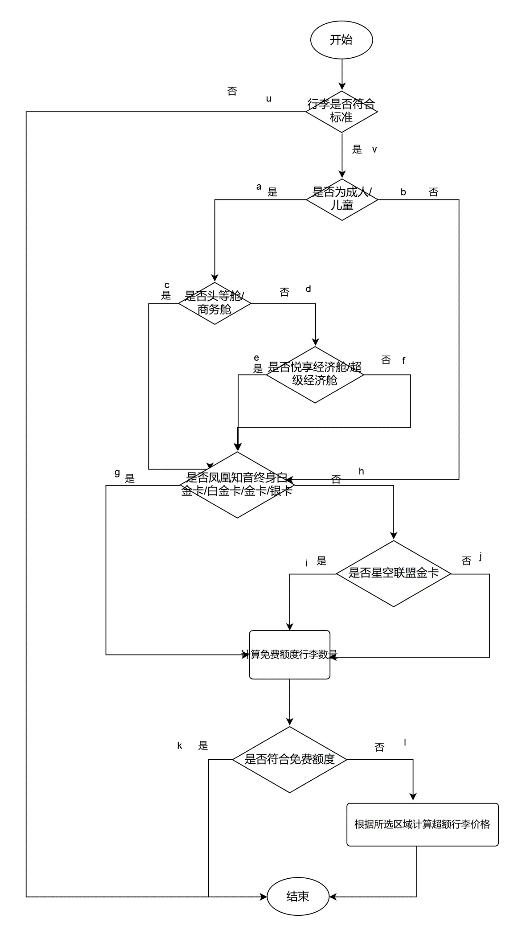

**4.2.2 输入**

乘客类型、会员等级、舱位等级、行李数量、各行李的规格及类型、飞行区域。

**4.2.3 输出**

错误数据返回-1；

运行正常返回的是行李托运计算结果

**4.2.4 测试用例**

**表4-2 国际航班测试用例设计表**

|  |  |  |  |
| --- | --- | --- | --- |
| 用例编号 | 通过路径 | 测试数据 | 期望结果 |
| 1 | u | {"region":"r1","person":"成人","seat_type":"s5","flight_type":"国际航班","vip":"v0","num":"2","length1":"90 90 90 10","type1":"普通行李","length2":"40 40 40 12","type2":"A类运动器械器具","length3":"","type3":"","price":"5000"} | -1 |
| 2 | v-a-c-g-k | {"region":"r4","person":"成人","seat_type":"s1","flight_type":"国际航班","vip":"v1","num":"2","length1":"30 30 30 10","type1":"普通行李","length2":"40 40 40 12","type2":"A类运动器械器具","length3":"","type3":"","price":"5000"} | 0 |
| 3 | v-a-c-g-l | {"region":"r1","person":"成人","seat_type":"s1","flight_type":"国际航班","vip":"v1","num":"2","length1":"50 60 70 10","type1":"普通行李","length2":"41 40 40 12","type2":"A类运动器械器具","length3":"","type3":"","price":"5000"} | 980 |
| 4 | v-a-c-h-i-k | {"region":"r3","person":"成人","seat_type":"s1","flight_type":"国际航班","vip":"v5","num":"2","length1":"30 30 30 10","type1":"普通行李","length2":"42 40 40 12","type2":"A类运动器械器具","length3":"","type3":"","price":"5000"} | 0 |
| 5 | v-a-c-h-i-l | {"region":"r2","person":"成人","seat_type":"s1","flight_type":"国际航班","vip":"v5","num":"2","length1":"50 60 70 10","type1":"普通行李","length2":"43 40 40 12","type2":"A类运动器械器具","length3":"","type3":"","price":"5000"} | 690 |
| 6 | v-a-c-h-j-k | {"region":"r2","person":"成人","seat_type":"s1","flight_type":"国际航班","vip":"v0","num":"2","length1":"30 30 30 10","type1":"普通行李","length2":"44 40 40 12","type2":"A类运动器械器具","length3":"","type3":"","price":"5000"} | 0 |
| 7 | v-a-c-h-j-l | {"region":"r3","person":"成人","seat_type":"s1","flight_type":"国际航班","vip":"v0","num":"2","length1":"50 60 70 10","type1":"普通行李","length2":"45 40 40 12","type2":"A类运动器械器具","length3":"","type3":"","price":"5000"} | 520 |
| 8 | v-a-d-e-g-k | {"region":"r5","person":"成人","seat_type":"s3","flight_type":"国际航班","vip":"v1","num":"2","length1":"30 30 30 10","type1":"普通行李","length2":"46 40 40 12","type2":"A类运动器械器具","length3":"","type3":"","price":"5000"} | 0 |
| 9 | v-a-d-e-g-l | {"region":"r4","person":"成人","seat_type":"s3","flight_type":"国际航班","vip":"v1","num":"2","length1":"50 60 70 10","type1":"普通行李","length2":"47 40 40 12","type2":"A类运动器械器具","length3":"","type3":"","price":"5000"} | 1040 |
| 10 | v-a-d-e-h-i-k | {"region":"r2","person":"成人","seat_type":"s3","flight_type":"国际航班","vip":"v5","num":"2","length1":"30 30 30 10","type1":"普通行李","length2":"48 40 40 12","type2":"A类运动器械器具","length3":"","type3":"","price":"5000"} | 0 |
| 11 | v-a-d-e-h-i-l | {"region":"r5","person":"成人","seat_type":"s3","flight_type":"国际航班","vip":"v5","num":"2","length1":"50 60 70 10","type1":"普通行李","length2":"49 40 40 12","type2":"A类运动器械器具","length3":"","type3":"","price":"5000"} | 520 |
| 12 | v-a-d-e-h-j-k | {"region":"r1","person":"成人","seat_type":"s3","flight_type":"国际航班","vip":"v0","num":"2","length1":"30 30 30 10","type1":"普通行李","length2":"50 40 40 12","type2":"A类运动器械器具","length3":"","type3":"","price":"5000"} | 0 |
| 13 | v-a-d-e-h-j-k-l | {"region":"r1","person":"成人","seat_type":"s3","flight_type":"国际航班","vip":"v0","num":"2","length1":"50 60 70 10","type1":"普通行李","length2":"51 40 40 12","type2":"A类其他特殊行李","length3":"","type3":"","price":"5000"} | 980 |
| 14 | v-a-d-f-g-k | {"region":"r3","person":"成人","seat_type":"s5","flight_type":"国际航班","vip":"v1","num":"2","length1":"30 30 30 10","type1":"普通行李","length2":"52 40 40 12","type2":"A类其他特殊行李","length3":"","type3":"","price":"5000" | 0 |
| 15 | v-a-d-f-g-l | {"region":"r2","person":"成人","seat_type":"s5","flight_type":"国际航班","vip":"v1","num":"2","length1":"50 60 70 10","type1":"普通行李","length2":"53 40 40 12","type2":"A类其他特殊行李","length3":"","type3":"","price":"5000"} | 690 |
| 16 | v-a-d-f-h-i-k | {"region":"r3","person":"成人","seat_type":"s5","flight_type":"国际航班","vip":"v5","num":"2","length1":"30 30 30 10","type1":"普通行李","length2":"54 40 40 12","type2":"A类其他特殊行李","length3":"","type3":"","price":"5000"} | 0 |
| 17 | v-a-d-f-h-i-l | {"region":"r3","person":"成人","seat_type":"s5","flight_type":"国际航班","vip":"v5","num":"2","length1":"50 60 70 10","type1":"普通行李","length2":"55 40 40 12","type2":"A类其他特殊行李","length3":"","type3":"","price":"5000"} | 520 |
| 18 | v-a-d-f-h-j-k | {"region":"r2","person":"成人","seat_type":"s5","flight_type":"国际航班","vip":"v0","num":"2","length1":"30 30 30 10","type1":"普通行李","length2":"56 40 40 12","type2":"A类其他特殊行李","length3":"","type3":"","price":"5000"} | 0 |
| 19 | v-a-d-f-h-j-l | {"region":"r4","person":"成人","seat_type":"s5","flight_type":"国际航班","vip":"v0","num":"2","length1":"50 60 70 10","type1":"普通行李","length2":"57 40 40 12","type2":"A类其他特殊行李","length3":"","type3":"","price":"5000"} | 1040 |
| 20 | v-b-g-k | {"region":"r5","person":"婴儿","seat_type":"s4","flight_type":"国际航班","vip":"v1","num":"2","length1":"30 30 30 10","type1":"普通行李","length2":"58 40 40 12","type2":"A类其他特殊行李","length3":"","type3":"","price":"5000"} | 0 |
| 21 | v-b-g-l | {"region":"r5","person":"婴儿","seat_type":"s4","flight_type":"国际航班","vip":"v1","num":"2","length1":"50 60 70 10","type1":"普通行李","length2":"59 40 40 12","type2":"A类其他特殊行李","length3":"","type3":"","price":"5000"} | 520 |
| 22 | v-b-h-i-l | {"region":"r1","person":"婴儿","seat_type":"s4","flight_type":"国际航班","vip":"v5","num":"2","length1":"30 30 30 10","type1":"普通行李","length2":"60 40 40 12","type2":"A类其他特殊行李","length3":"","type3":"","price":"5000"} | 0 |
| 23 | v-b-h-i-k | {"region":"r1","person":"婴儿","seat_type":"s4","flight_type":"国际航班","vip":"v5","num":"2","length1":"50 60 70 10","type1":"普通行李","length2":"61 40 40 12","type2":"A类其他特殊行李","length3":"","type3":"","price":"5000"} | 980 |
| 24 | v-b-h-j-k | {"region":"r4","person":"婴儿","seat_type":"s4","flight_type":"国际航班","vip":"v0","num":"2","length1":"30 30 30 10","type1":"普通行李","length2":"62 40 40 12","type2":"A类其他特殊行李","length3":"","type3":"","price":"5000"} | 0 |
| 25 | v-b-h-j-l | {"region":"r2","person":"婴儿","seat_type":"s4","flight_type":"国际航班","vip":"v0","num":"2","length1":"50 60 70 10","type1":"普通行李","length2":"63 40 40 12","type2":"A类其他特殊行李","length3":"","type3":"","price":"5000"} | 690 |

白盒测试覆盖率：100%

注：由于对于超重超尺寸超件数的行李，其在各个区域中的处理逻辑相似，因此为精简测试内容，我并未设计针对某一个区域的单独测试，而是随机选择某一区域进行测试

# 二、单元测试框架

## 1. 测试环境的安装与配置

测试框架我选择了Junit5, 配置过程是在maven中引入依赖：

<dependency>  
 <groupId>junit</groupId>  
 <artifactId>junit</artifactId>  
 <version>5.13.1</version>  
 <scope>test</scope>  
</dependency>

## 2. 测试过程

为了使测试过程自动化，经搜索后我发现可以在excel中将测试数据内容写好，转换成json数据后，在程序中读取json文件并对其进行解析转化为String格式，并采用JSON.parseArray(jsonContent, Form.class)函数对String进行切割，原始数据转换为列表，之后循环测试当列表元素作为参数时，其在程序中计算的结果是否与期望结果相同，若全部相同则测试通过。

### 2.1 测试对象1：黑盒测试

**2.1.1 单元描述**

该测试单元的目的将上述黑盒测试的测试用例的期望值与实际值进行比较，查看是否相同。

**2.1.2 单元结构**

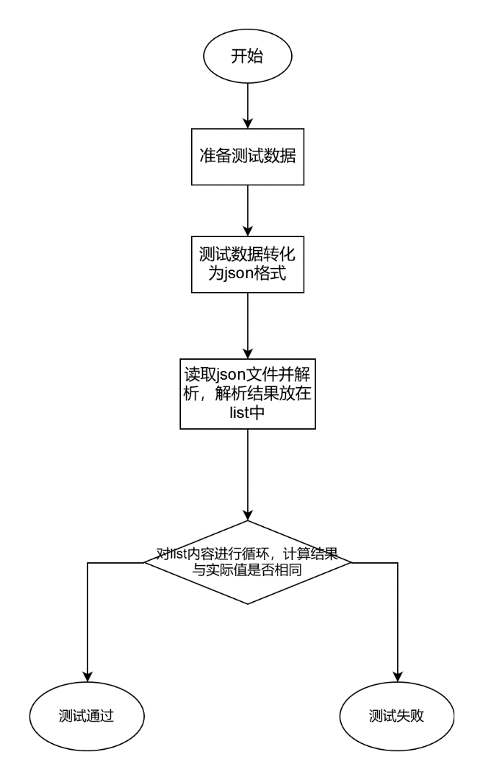

**2.1.3 测试代码**

1. public static String FileUtil(String Path) throws IOException {
2. BufferedReader reader = null;
3. StringBuilder laststr = new StringBuilder();
4. FileInputStream fileInputStream = new FileInputStream(Path);
5. InputStreamReader inputStreamReader = new InputStreamReader(fileInputStream, StandardCharsets.UTF_8);
6. reader = new BufferedReader(inputStreamReader);
7. String tempString = null;
8. while ((tempString = reader.readLine()) != null) {
9. laststr.append(tempString);
10. }
11. reader.close();
12. return laststr.toString();
13. }
14. @Test
15. public void UnitTest(List<Form> list) {
16. Calc calc = new Calc();
17. int res = 0;
18. for (int i=0;i<list.size();i++) {
19. res = calc.calculatePrice(list.get(i));
20. assertEquals("测试成功", res,list.get(i).getRes());
21. System.out.println("第"+(i+1)+"项测试通过");
22. }
23. }
24. @Test
25. public void BlackTest() throws IOException {
26. String filePath = "src/main/java/Test/黑盒测试.json";
27. String jsonContent = FileUtil(filePath);
28. List<Form> list = JSON.parseArray(jsonContent, Form.class);
29. UnitTest(list);
30. }

### 2.2 测试对象2：白盒测试-国内航班测试

**2.2.1 单元描述**

该测试单元的目的将上述白盒测试中针对国内航班的的测试用例的期望值与实际值进行比较，查看是否相同。

**2.2.2 单元结构**

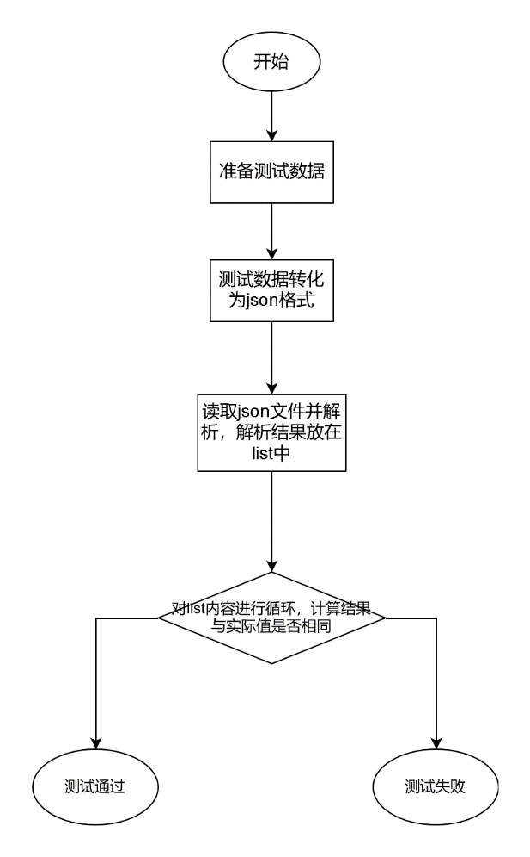

**2.2.3 测试代码**

1. public static String FileUtil(String Path) throws IOException {
2. BufferedReader reader = null;
3. StringBuilder laststr = new StringBuilder();
4. FileInputStream fileInputStream = new FileInputStream(Path);
5. InputStreamReader inputStreamReader = new InputStreamReader(fileInputStream, StandardCharsets.UTF_8);
6. reader = new BufferedReader(inputStreamReader);
7. String tempString = null;
8. while ((tempString = reader.readLine()) != null) {
9. laststr.append(tempString);
10. }
11. reader.close();
12. return laststr.toString();
13. }
14. @Test
15. public void UnitTest(List<Form> list) {
16. Calc calc = new Calc();
17. int res = 0;
18. for (int i=0;i<list.size();i++) {
19. res = calc.calculatePrice(list.get(i));
20. assertEquals("测试成功", res,list.get(i).getRes());
21. System.out.println("第"+(i+1)+"项测试通过");
22. }
23. }
24. @Test
25. public void WhiteTestin() throws IOException {
26. String filePath = "src/main/java/Test/白盒测试-国内航班.json";
27. String jsonContent = FileUtil(filePath);
28. List<Form> list = JSON.parseArray(jsonContent, Form.class);
29. UnitTest(list);
30. }

### 2.3 测试对象3：白盒测试-国际航班测试

**2.3.1 单元描述**

该测试单元的目的将上述白盒测试中针对国外航班的测试用例的期望值与实际值进行比较，查看是否相同。

**2.3.2 单元结构**

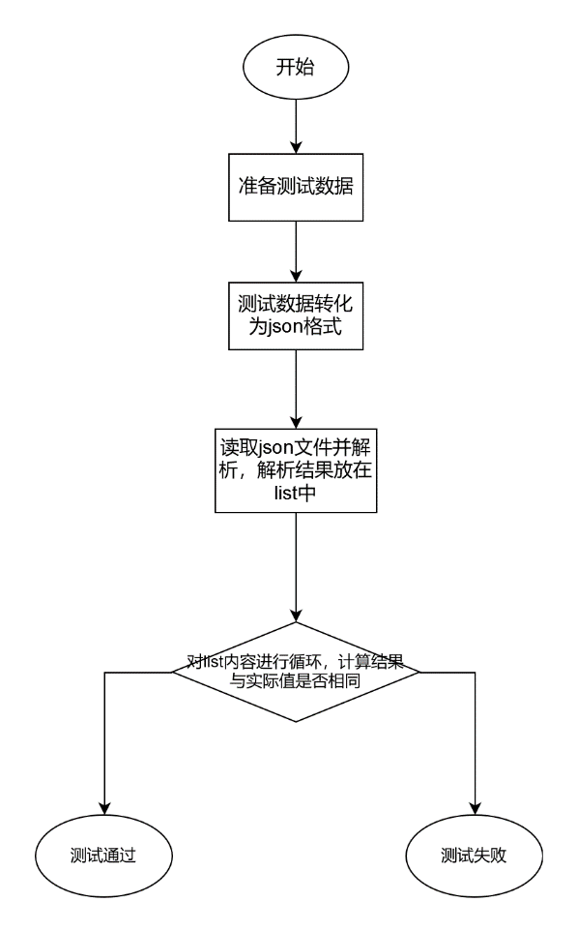

**2.3.3 测试代码**

1. public static String FileUtil(String Path) throws IOException {
2. BufferedReader reader = null;
3. StringBuilder laststr = new StringBuilder();
4. FileInputStream fileInputStream = new FileInputStream(Path);
5. InputStreamReader inputStreamReader = new InputStreamReader(fileInputStream, StandardCharsets.UTF_8);
6. reader = new BufferedReader(inputStreamReader);
7. String tempString = null;
8. while ((tempString = reader.readLine()) != null) {
9. laststr.append(tempString);
10. }
11. reader.close();
12. return laststr.toString();
13. }
14. @Test
15. public void UnitTest(List<Form> list) {
16. Calc calc = new Calc();
17. int res = 0;
18. for (int i=0;i<list.size();i++) {
19. res = calc.calculatePrice(list.get(i));
20. assertEquals("测试成功", res,list.get(i).getRes());
21. System.out.println("第"+(i+1)+"项测试通过");
22. }
23. }
24. @Test
25. public void WhiteTestout() throws IOException {
26. String filePath = "src/main/java/Test/白盒测试-国际航班.json";
27. String jsonContent = FileUtil(filePath);
28. List<Form> list = JSON.parseArray(jsonContent, Form.class);
29. UnitTest(list);
30. }

## 3. 测试结果

**黑盒测试**：对于黑盒测试，我创建了20条测试用例，均通过测试，结果如下：

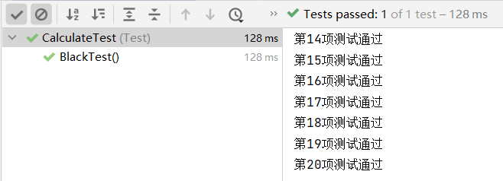

**白盒测试-国内航班**：对于国内航班的白盒测试，我创建了17条测试用例，均通过测试，结果如下：

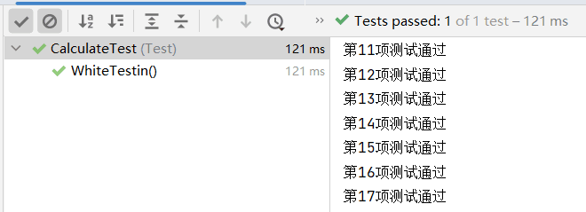

**白盒测试-国际航班**：对于国际航班的白盒测试，我创建了25条测试用例（由于对于超重超尺寸超件数的行李，其在各个区域中的处理逻辑相似，因此为精简测试内容，我并未设计针对某一个区域的单独测试，而是随机选择某一区域进行测试），均通过测试，结果如下：

